Machine Learning Introduction
What is Machine Learning?

Teaching a computer to learn from the data and make decisions by itself, without being explicitly programmed for each step.

In short:

Normal Programming -> You write rules -> Then Computer Follows

Machine Learning -> You give data -> Computer learns the rules

How Machine Learning Works?

Machine Learning has 3 steps:

- Data (Experience)

Examples:
- Marks of students
- Photos of Cats or Dogs
- House Prices

- Learning (Finding Patterns)

- Decision / Prediction

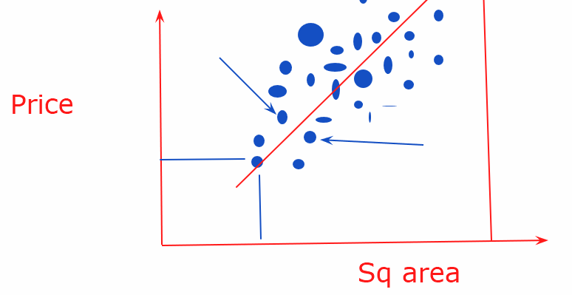

ML vs AI:

AI -> Artificial Intelligence

Giving intelligence to non-human beings.

Machine Learning is subset of AI.

Machine Learning is an AI that learns from the data instead of rules.

—----------------------------------------------------------------------------------------

Let us understand DATA.

There are 2 types of information about data which ML uses:

- Features
- Labels / Targets

Example Data:

Daily avg Hours Studied | Class Attendance | Tests attempted | Result
1.5 | 80% | 5 | Pass
2 | 90% | 7 | Fail
4 | 95% | 2 | Pass

Question is: Based on information for the first 3 columns, we need to predict the result.

Label / Target: What we need to predict
Result

Features:
Daily Avg Hours Studied
Class Attendance
Tests Attempted
Features: the information you give to the machine to make a prediction

Labels / Target : final data you want to predict

—---------------------------------------------------------------------------

House Prices:
1000 rows of data

800 rows of data given to the Machine to get trained.

200 rows of data for testing the Machine Learning Model.

Total Data:
- Training Data (for teaching the model)
- Testing Data (for checking if the machine really learned)

Training Process:
- Both features and labels are given
- Model is developed
- Model is optimized

Testing Process:
- Only features are given to the model
- Model predicts the labels
- We compare the predicted label with the actual labels
- Measure Accuracy

—----------------------------------------------------------------------------

Model Fitting:

- Overfitting
- Underfitting

Overfitting:

Model performed extremely well on the TRAINING DATA, but performed POORLY on the TESTING DATA

Model memorizes training data instead of learning.
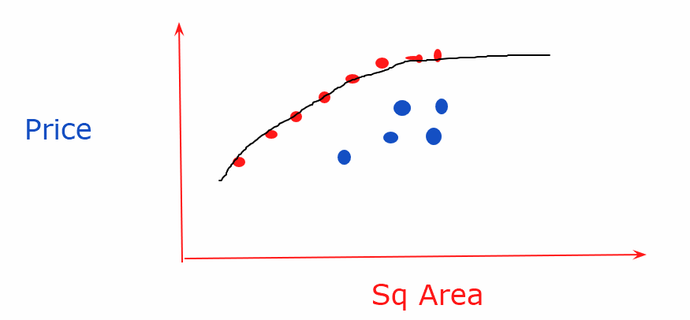

Underfitting:

Model is too simple
Model did not learn much about the relationship between features and labels.

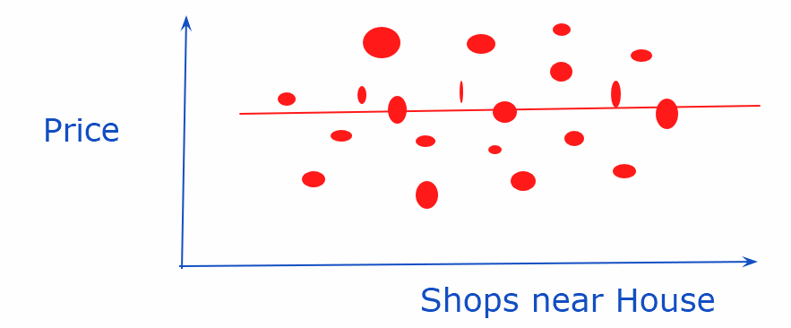
Nothing learned from the data. Price and shops near house doesn’t have a relationship.

—---------------------------------------------------------------------

Types of Machine Learning:

- Supervised Learning
- Unsupervised Learning

Supervised Learning:

Learning with:
Features and Labels

Examples:
Student Pass/Fail
Email Spam or Not
House Price Prediction

Unsupervised Learning:

- Only features are available, NO LABELS

Example:

Customer Segmentation

Segments can be: High Value, Medium Value, Low Value

Student Grouping: High Performers, Low Performers

—---------------------------------------------------------------

Types of Machine Learning Problems:

- Regression Problem: Output is continuous (Numeric)

Example: House Price Prediction, Company sales Prediction, Employe salary prediction….

y = 2 (x) + 5

If x = 10 -> y = 25

- Classification Problem: Output is finite and defined.

Example: Student (Pass/Fail), Email (spam/Not Spam)...

—-------------------------------------------------------------------

Basic Statistics:

Marks | Mean (average) | Spread | Variance
60 | 71.6 | 20 | x
75 | 71.6 | 20 | x
80 | 71.6 | 20 | x

Variance = [(m1 - mean)^2 + (m2 - mean)^2 + (m3 - mean)^2] / 3

Standard Deviation = SQRT of Variance

Variance is the magnitude of deviation of values from the mean.

—---------------------------------------------------------

Original Values: 1,2,3
Mean = 2
SD = SQRT [ ((1 - 2)^2 + (2 - 2)^2 + (3 - 2)^2) / 3 ]
SD = SQRT of (1 + 0 + 1) / 3 = 0.66
SD = 0.81

Z score = (values - mean) / SD

Corresponding Z values = -1.2 , 0 , 1.2

Normalization:
Spread (Max - Min) = 2

Norm_values = 0 , 0.5 , 1

Original values: 1000, 2000, 3000

Mean = 2000
Assume SD = 1000

Corresponding Z values = -1 , 0 , 1

Norm_values = 0 , 0.5, 1

Linear Regression
Linear Regression

It is supervised machine learning.

Regression is finding a line which best fits our data points.

Example:

Predicting house price from size.

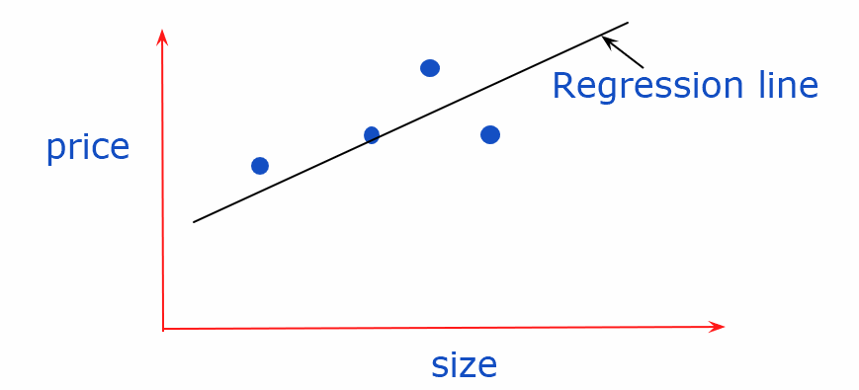

The Regression line is an equation.

Y = mx + c

M = slope
C = Intercept

M = weight of the variable = change in y per unit change in x

Intercept = Y when X is 0

Ex. y = 3x + 5

X = 10 | y = 35

X = 11 | y = 38

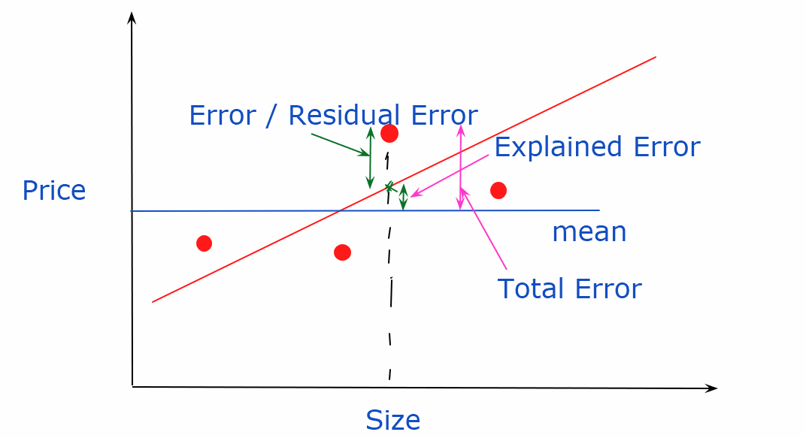

Total Error = Overall error
Explained Error = Error explained by the model
Residual Error = Error still left in the data

Model Evaluation (how good the model is) is determined by how much error is explained by the model from the overall error.

For evaluating the errors in absolute values, we use square of values.

Total Sum of Squares (TSS) -> Total Error in the model

Explained Sum of Squares (ESS) -> Error explained by the model

Residual Sum of Squares (RSS) -> Error left in the model

TSS = ESS + RSS

Model / Best Fit line is where the RSS is minimum.
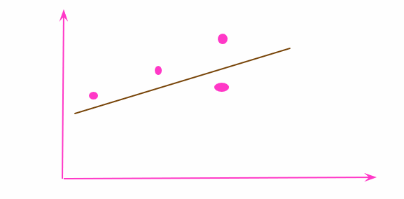
How good the model is is determined by R-square value

R-square = [ESS / TSS] = [1 - RSS / TSS]

Range of R-squared value is between 0 and 1.

Higher value means a better model.

—-----------------------------------------------------------------

Simple Linear Regression -> Single feature

Y = mx + c

Multiple Linear Regression -> Multiple features

Y = m1 x1 + m2 x2 + m3 x3 +...........mn xn + C

—----------------------------------------------------------------

Mean squared Error

Logistic Regression
Logistic regression:

- Supervised learning model
- Used for classification problems

You start with -> Linear Regression Model:
Y = m1x1 + m2X2 + m3X3 + ………….+ C

Then you pass the output in a sigmoid Function:

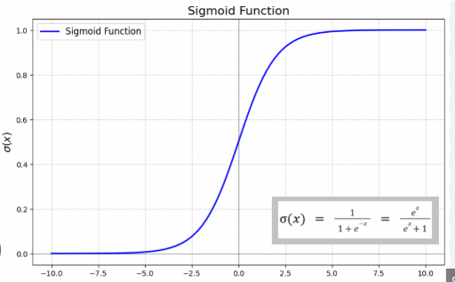

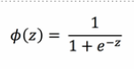

Decision Boundary:

This is the value where the probability is converted into a class of value (like Yes / No, Spam/ Not Spam etc)

Model Evaluation:

Confusion Matrix:

 | Predicted Yes | Predicted No
Actual Yes | True Positive (TP) | False Negative (FN)
Actual No | False Positive (FP) | True Negative (TN)

Model Accuracy: (TP + TN) / Total Predictions

Regularization
Regularization

Model Overfitting:

Example: Linear Regression

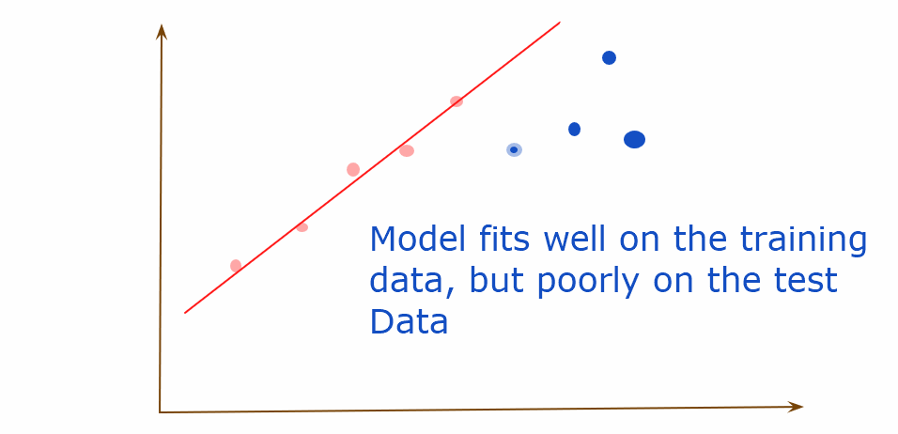

Example: Polynomial Model

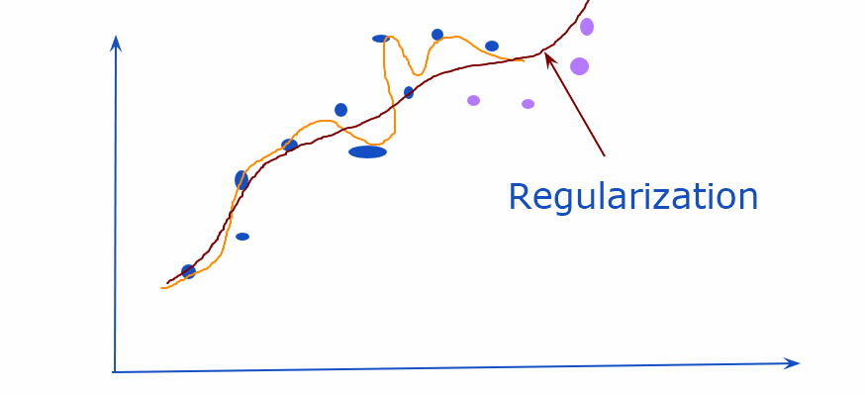

What is Regularization?

Introducing error to the data model.

Ex. In linear regression model, minimum RSS is used to find the best fit line.

In Regularization:

New RSS = Prediction error for best fit line (Old RSS) + Penalty (Additional error)

Features with Higher Weights are Penalized More. Features with Lower Weights are Penalized Less.

—------------------------------------------------------------------------------------------

Ridge Regression (L2 Regularization):

Penalty = Lambda X (Sum of Square of Weights)

Penalty = Lambda X (w1^2 + w2^2 + w3^2 +......................+ wn^2)

Lambda -> how severe penalty is applied

When to use Ridge regression:
- You don’t want to reduce the feature
- When some features are correlated

—------------------------------------------------------------------------------------------

Lasso Regression (L1 Regularization):

Penalty = lambda x (sum of absolute weights)

Penalty = lambda x (|W1| + |W2| + …………|Wn| )

When to use Lasso regression:
- We want feature reduction

—---------------------------------------------------------------------------------------------

Elastic Net (L1 + L2 together):

- Lasso will drop the useless features
- Ridge will handle the correlated features

—-------------------------------------------------------------------------------------------

K-means Clustering
K Means Clustering

K means clustering is an unsupervised machine learning algorithm

It is used to group similar data points together.

Each group is called a Cluster.

Example:

If there is marks data, and we want to make 3 groups (High marks, medium Marks, Low Marks).

—-----------------------------------------------------------------------

What is K?

K = number of clusters we want, we define the value of K

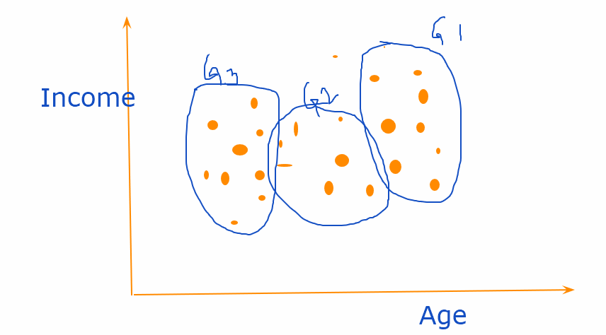

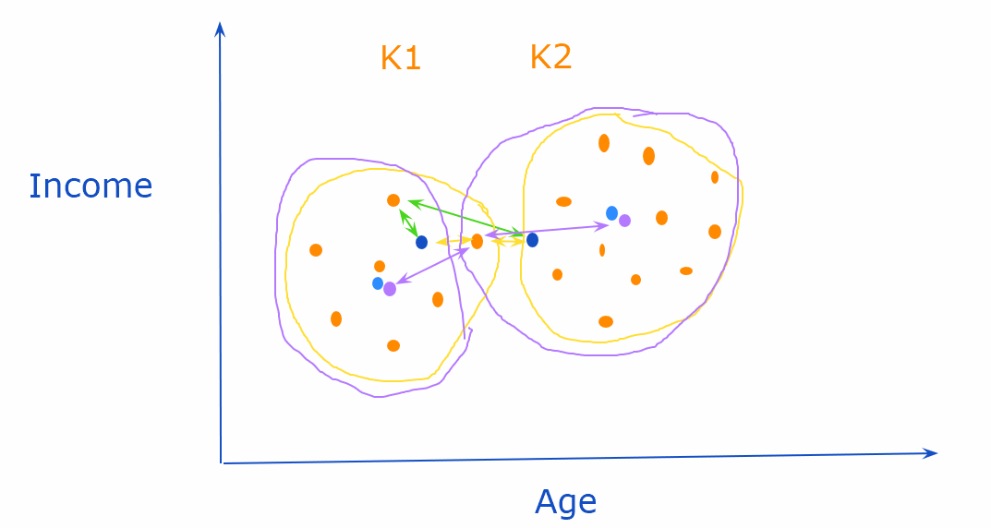

Steps of K Means Algorithm:

- K is declared
- Random k data points are created
- Distance between each datapoint with each K data points is calculated and the first set of clusters are created. Distance is usually Euclidean Distance.
- Centroid of each cluster is calculated.

Example: x1,y1 = 1, 3 | x2, y2 = 4, 6 | x3, y3 = 2,3

Centroid = x1 + x2 + x3 / 3 , y1 + y2 + y3 / 3 = 2.3, 4

- Distance between new centroid and all data points is calculated and depending on the minimum distance, data points stay/move between clusters.
- This process keeps repeating till the centroids stops moving.

—----------------------------------------------------------------------------

When should we stop making the clusters.

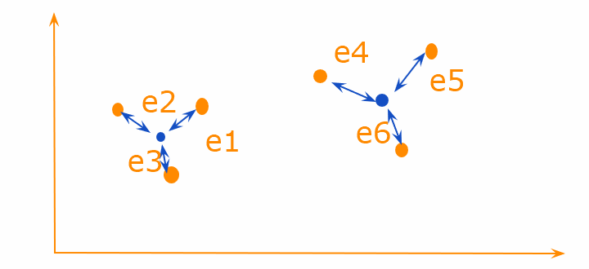

WCSS (Within Cluster Sum of Squared Error)

= (e1^2 + e2^2 + e3^2) + (e4^2 + e5^2 + e6^2)

Ex. e1 = x1^2 - u(c1) ^2

WCSS keeps reducing with increased Ks.

Chart between WCSS and K

Elbow Method to find the optimum K value:
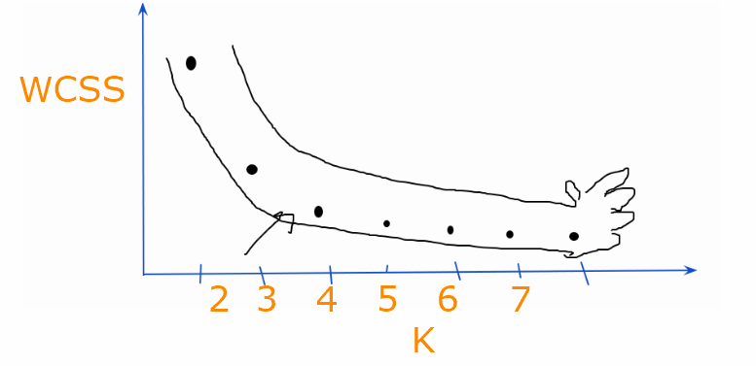

Decision Tree
Decision Tree

Decision Tree is a supervised machine learning algorithm.

It is a classification technique.

Problem with Decision Tree:

It tries to memorise the data.

It gives 100% accurate results on the training data but the accuracy reduces on the test data.

Example:

Temperature: 98.5 , 98.6, 98.7…………….

Rain or Not: Yes, No, Yes

Decision Tree tries to overfit.

—----------------------------------------------------------------

How can overfitting be handled?

We can add some controls in the decision tree model.

Controls:

Max_depth:
- Tree can only grow a limited level deep (example - 4 level)
- Forces it to learn general patterns
- Prevents ‘micro rules’

Min_samples_leaf = 10

- Every leaf node must contain at least (lets say 10) samples
- This ensures that the decision is not based on very few samples.

These controls are also called Hyper parameters.

Other controls:

Min_samples_split

- How many splits to do from a node (default = 2)

Max_features

- Number of features to consider

Random Forest
Random Forest:

Supervised Machine Learning Algorithm. It uses Decision Tree as the base.

In Random Forest, multiple decision trees are trained and then voting is taken from each tree to get the final prediction.

Here, instead of trusting one tree, we trust a forest of multiple trees.

Q: How can it create multiple decision trees from the same data points?

Multiple trees are created because it considers different samples and different features.

For ex: 1000 data points (rows) and 6 features

DT1 -> 600 rows, 5 features
DT2 -> 700 rows, 4 features
DT3 -> 500 rows, 6 features

Steps:
- Original Data -> Training samples are picked
- From the training sample, random N samples are created.
- Features are randomly picked
- Different DTs are created
- Majority vote decides the final classification.

Hyper Parameters
Hyper parameters are the controls that can be added to the machine learning models.

Hyper parameters in DT / RF:

- N Samples
- Min_samples_leaf
- Max_depth
- Max_split

Hyper parameter Tuning:

Finding the best combination of the hyper parameters.

There are 2 components in HP Tuning:

- Cross Validation

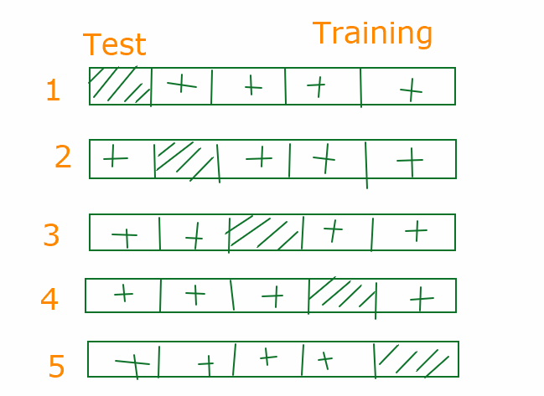

This is an example of 5 fold cross validation.
Optimum Hyper parameter values.

- Grid Search CV
- Randomized Search CV

KNN
KNN -> K Nearest Neighbours

KNN is a supervised machine learning algorithm. Generally used for classification problems.

KNN looks at the K nearest data points and decides based on the majority vote.

What is K?
- Number of nearest neighbours.

Steps for KNN:

- Choose the value of K
- Calculate the distance between the New data point with all data points used in training dataset
- Sorting all the distances (arranging data points from smallest to largest distance)
- Pick the top K nearest
- Get voting, give final predictions based on majority.

KNN is all called Lazy algorithm.

Because:
- It doesn’t really learn from the data
- It stores all the data
- It calculates everything during prediction

Support Vector Machine
Support Vector Machine (SVM)

It is a supervised ML algorithm. It is generally used for classification problems.

Example:

Lets say I have 2 features of Car, and I need to predict the make of the car (Suzuki / BMW)

Features: Price, Safety Index

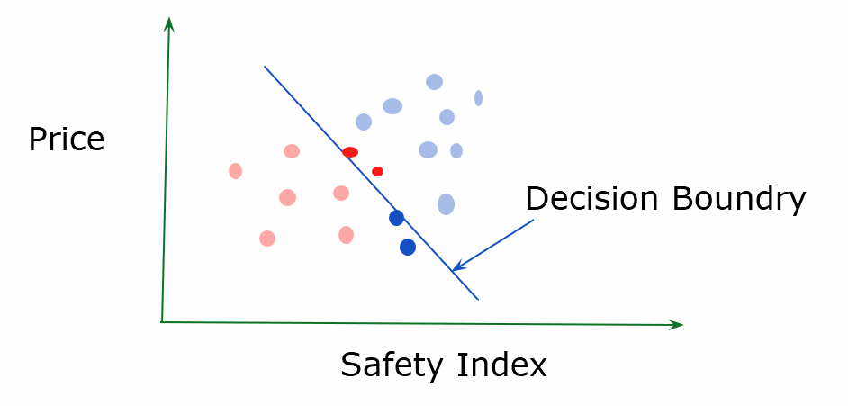

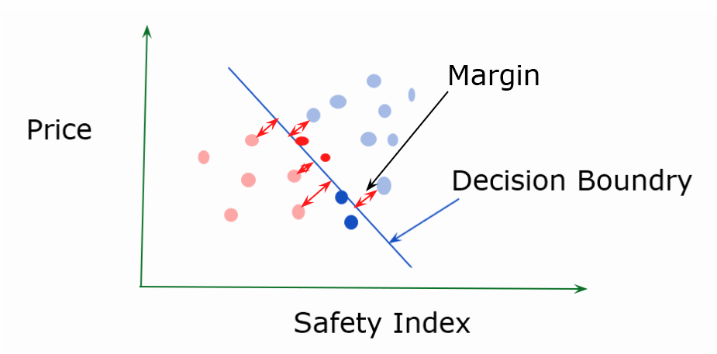

How to determine the decision boundary?

SVM draws a decision boundary line/plane such that it maximises margin between the classification groups.

For 3D: A plane is created as the decision boundary.

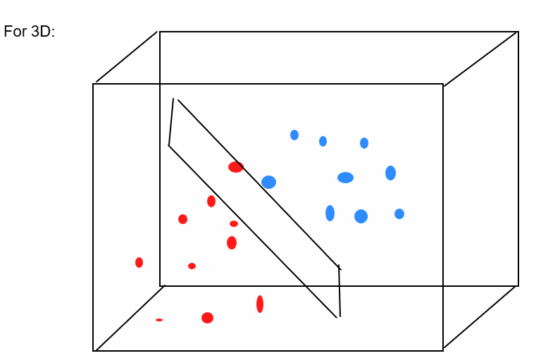

Decision boundary is also called hyperplane.

SVM draws a hyperplane in N dimensional space such that it maximises the margin between the groups.
Hyperparameters of SVM:

- Gamma
- C
- Kernel

Gamma:

High Gamma -> considers only nearby data points for margin calculation
Low Gamma -> considers even faraway points for the decision boundary / margin calculation.

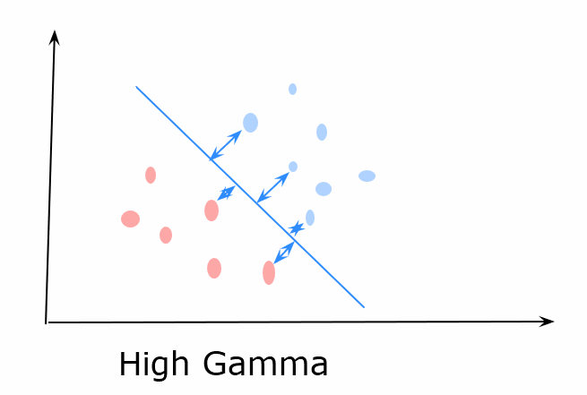

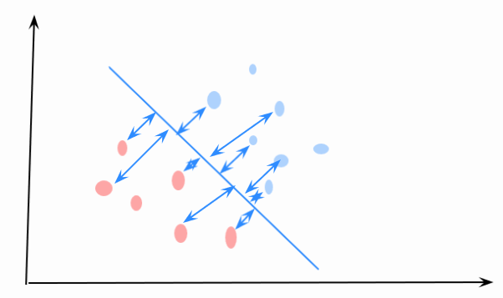

LOW GAMMA

C (Regularization)

High C -> Decision boundary is created with keeping minimum errors. Tries to overfit the data.

Low C -> Simplifies the decision boundary with smother curves and allows erorrs in the training data.

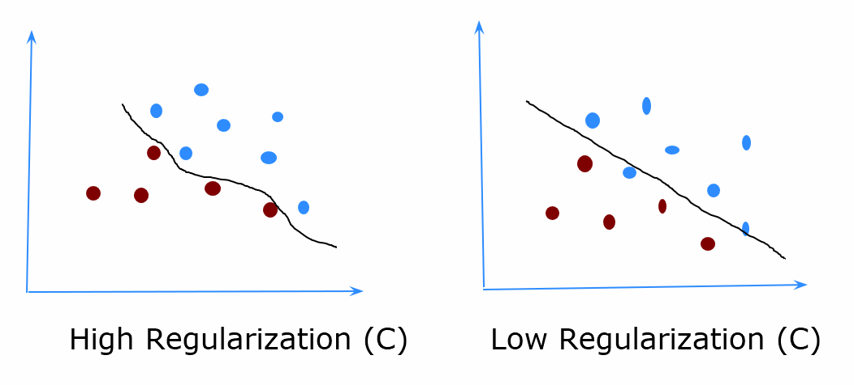

Kernel

Shape of the decision boundary (Linear, non-linear (rbf) , polynomial etc)

Non-linear is the most common kernel

Dimensionality Reduction
Dimensionality Reduction

It is done in 2 ways:

- Feature Selection
  - Selecting features that contributes to the prediction
- Feature Extraction

For Example:

Feature Selection -> we will pick only SQFT

SQFT | Nearby Medical Stores | Price
1000 | 5 | 500K
1500 | 8 | 900K
1600 | 2 | 1000k

No. of Bedrooms | No. of Bathrooms | Price
3 | 3 | 500K
2 | 3 | 300K

We can come up with a new feature: Total SQLFT Area

Total SQFT Area | Price

This is called feature extraction.

Principle Component Analysis (PCA)

PCA is a technique used for feature extraction, its also called a dimensionality reduction technique.

PCA is used to reduce high dimension data into low dimension data while saving the essence of the data.

Why PCA?
- Faster execution of Algorithm
- Low computation Cost
- Simpler Models
- Visualizing the data becomes easy

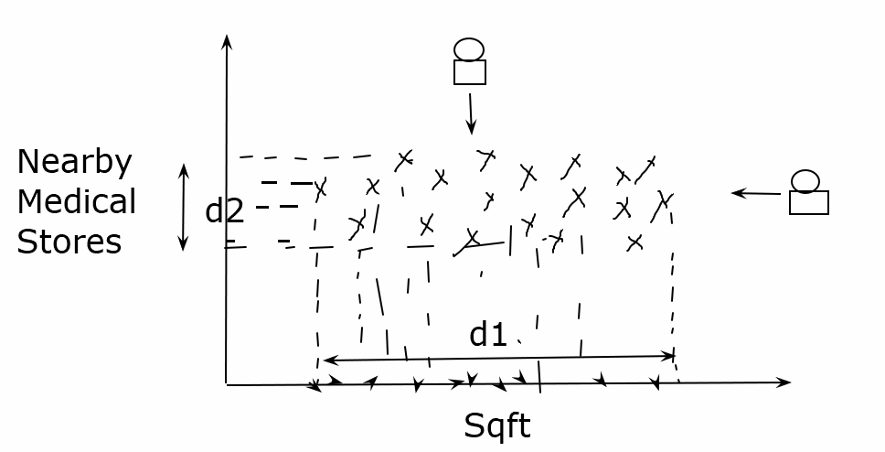

Feature with high variance (spread) is more important.

From the above scatter plot, we can say that Sqft is more important feature.

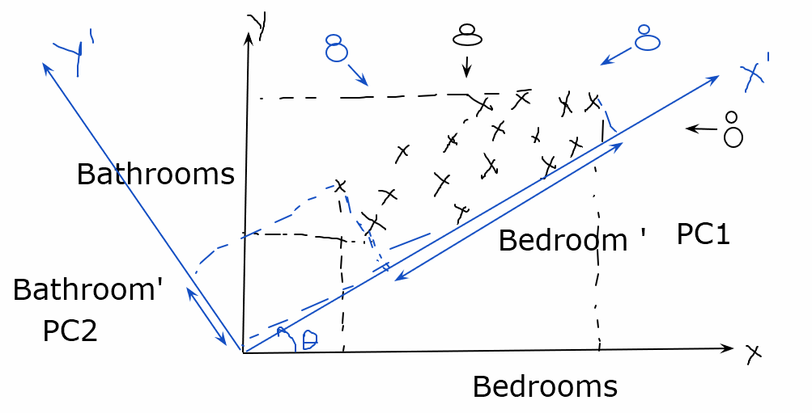

The new axis can be called PC1 and PC2.

And now we can only keep PC1 as the feature because the spread of PC1 is higher than PC2.

Covariance: Covariance explains the relationship between the variables (Positive, Negative or Neutral).

While Variance only tells us about the spread and magnitude, Covariance tells us about the relationship.

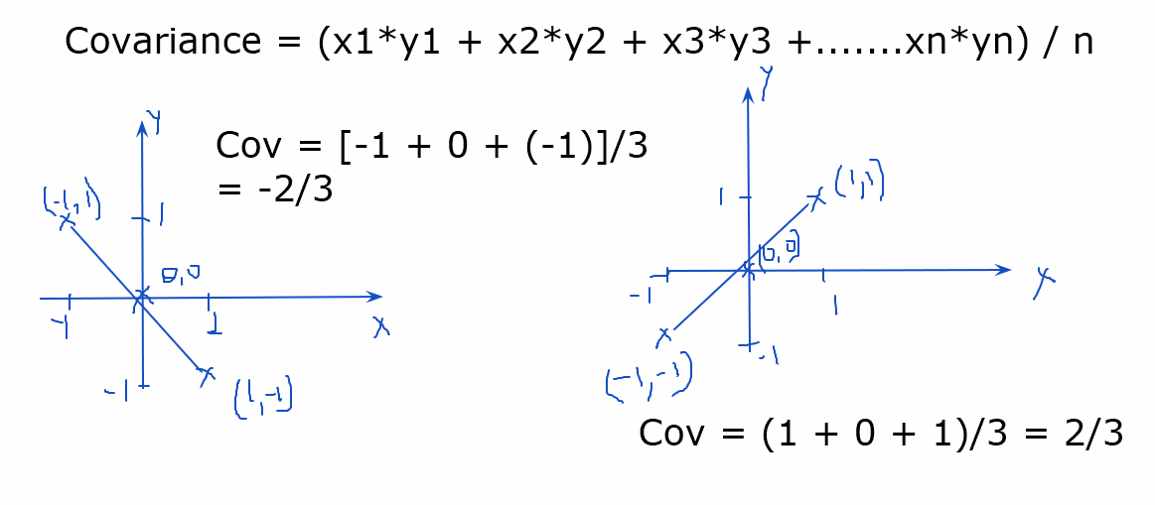

Covariance Matrix = Covariance between all the features.

Eigen Vector / Eigen value

Eigen Vectors are special vectors.

If we apply a matrix transformation to Eigen Vector, their magnitude changes but their direction remains the same.

The Magnitude of the change is called ‘Eigen Value’.

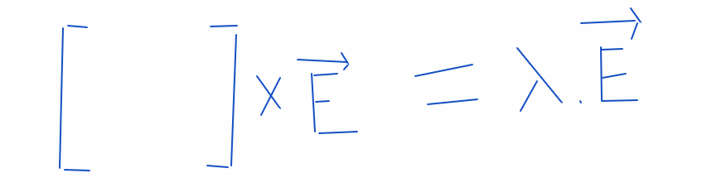

—-----------------------------------------------------

Step wise Approach for PCA:

- Mean center the Data
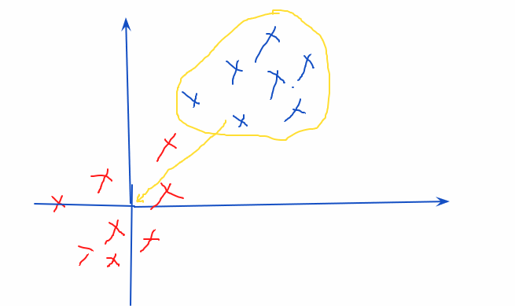
- Find the covariance matrix
- Find the Eigen Vector and Eigen Value
  - Largest Eigen Vector is PC1, Second Largest EV is PC2 and so on
- Now we can keep only the top PCs and reduce the dimensions

